***Dissertation on***

**Recipe Recommendation Based On Ingredients Recognition Using CV and ML**

*Submitted in partial fulfilment of the requirements for the award of degree of*

**Bachelor of Technology**

**in**

**Computer Science & Engineering**

**UE19CS390A – Capstone Project Phase - 1**

***Submitted by:***

| **A R Manyatha**  **Amulya S Dinesh**  **Manasi Swain**  **Mihir Soni** | **PES2UG19CS002**  **PES2UG19CS035**  **PES2UG19CS216**  **PES2UG19CS232** |
| --- | --- |

*Under the guidance of*

| **Prof. Swati Pratap Jagdale**  Assistant Professor  PES University |
| --- |

**January - May 2022**

**DEPARTMENT OF COMPUTER SCIENCE AND ENGINEERING**

FACULTY OF ENGINEERING

**PES UNIVERSITY**

(Established under Karnataka Act No. 16 of 2013)

Electronic City, Hosur Road, Bengaluru – 560 100, Karnataka, India

**PES UNIVERSITY**

(Established under Karnataka Act No. 16 of 2013)

Electronic City, Hosur Road, Bengaluru – 560 100, Karnataka, India

**FACULTY OF ENGINEERING**

**CERTIFICATE**

*This is to certify that the dissertation entitled*

**Recipe Recommendation Based On Ingredients Recognition Using CV and ML**

*is a bonafide work carried out by*

| **A R Manyatha**  **Amulya S Dinesh**  **Manasi Swain**  **Mihir Soni** | **PES2UG19CS002**  **PES2UG19CS035**  **PES2UG19CS216**  **PES2UG19CS232** |
| --- | --- |

In partial fulfilment for the completion of sixth semester Capstone Project Phase - 1 (UE19CS390A) in the Program of Study -Bachelor of Technology in Computer Science and Engineering under rules and regulations of PES University, Bengaluru during the period Jan. 2022 – May. 2022. It is certified that all corrections / suggestions indicated for internal assessment have been incorporated in the report. The dissertation has been approved as it satisfies the 6th semester academic requirements in respect of project work.

| Signature  Prof. Swati Pratap Jagdale  Project Guide | Signature  Dr. Sandesh B J  Chairperson | Signature  Dr. B K Keshavan  Dean of Faculty |
| --- | --- | --- |

**External Viva**

| **Name of the Examiners**  **1.** __________________________  **2.** __________________________ | **Signature with Date**  __________________________    __________________________ |
| --- | --- |

**DECLARATION**

We hereby declare that the Capstone Project Phase - 1 entitled **“Recipe Recommendation Based On Ingredients Recognition Using CV and ML”** has been carried out by us under the guidance of Prof. Swati Pratap Jagdale and submitted in partial fulfilment of the course requirements for the award of degree of **Bachelor of Technology** in **Computer Science and Engineering** of **PES University, Bengaluru** during the academic semester January – May 2022. The matter embodied in this report has not been submitted to any other university or institution for the award of any degree.

| **PES2UG19CS002**  **PES2UG19CS035**  **PES2UG19CS216**  **PES2UG19CS232** | **A R Manyatha**  **Amulya S Dinesh**  **Manasi Swain**  **Mihir Soni** | **<Signature>**  **<Signature>**  **<Signature>**  **<Signature>** |
| --- | --- | --- |

**ACKNOWLEDGEMENT**

I would like to express my gratitude to Prof. Swati Pratap Jagdale, Department of Computer Science and Engineering, PES University, for her continuous guidance, assistance, and encouragement throughout the development of this UE19CS390A - Capstone Project Phase – 1.

I am grateful to the Capstone Project Coordinators, Dr.Sarasvathi V, Associate Professor and Dr. Sudeepa Roy Dey, Assistant Professor, for organizing, managing, and helping with the entire process.

I take this opportunity to thank Dr. Sandesh B J, Chairperson, Professor, Department of Computer Science and Engineering, PES University, for all the knowledge and support I have received from the department. I would like to thank Dr. B.K. Keshavan, Dean of Faculty, PES University for his help.

I am deeply grateful to Dr. M. R. Doreswamy, Chancellor, PES University, Prof. Jawahar Doreswamy, Pro Chancellor – PES University, Dr. Suryaprasad J, Vice-Chancellor, PES University for providing to me various opportunities and enlightenment every step of the way. Finally, this Capstone Project could not have been completed without the continual support and encouragement I have received from my family and friends.

**ABSTRACT**

Career, school, work, new adventures of life, those are often given priority. Eating healthy becomes the next important concern. So going to a fast food joint and preparing instant food may solve the problems related to food at the moment, but eventually it deteriorates health, either through weight fluctuation, energy loss, or both. Our system will help overcome this issue, by providing simple recipes which can be made by using ingredients available in the pantry as home cooked meals are proven to be nutritious and healthy.

We will be creating a recipe recommendation system using pictures/videos of the pantry for a variety of uses. Camera will be used to scan the various types of ingredients in the pantry and provide the user with all the dishes and recipes possible. Users will have an option to specify the type of diet along with calorie range.

The main aim of our proposed system is to help users to decide what they can cook with the available resources. By pointing the camera at the food ingredients, users can immediately build a plan or have an idea of what they will be cooking, based on our recommendations along with the nutritional value of the recipe.

**TABLE OF CONTENTS**

| **Chapter No.** | **Title** | **Page No.** |
| --- | --- | --- |
|  | **INTRODUCTION** | **01** |
|  | **PROBLEM DEFINITION** | **02** |
|  | **LITERATURE SURVEY**  3.1 Description of approach used  3.2 Result  3.3 Advantage  3.4 Limitations | **03** |
|  | **DATA**  4.1 Overview  4.2 Dataset | **07** |
|  | **SYSTEM REQUIREMENTS SPECIFICATION** | **08** |
|  | **SYSTEM DESIGN** |  |
|  | **CONCLUSION OF CAPSTONE PROJECT PHASE - 1** |  |
|  | **PLAN OF WORK FOR CAPSTONE PROJECT PHASE - 2** |  |
| **REFERENCES/BIBLIOGRAPHY** | |  |
| **APPENDIX A DEFINITIONS, ACRONYMS AND ABBREVIATIONS** | |  |

**APPENDIX B USER MANUAL**

| **LIST OF FIGURES**     | **Figure No.** | **Title** | **Page No.** | | --- | --- | --- | | **6.1** | **High level design diagram** |  | | **6.2** | **Multi-label Image Classification** |  | | **6.3** | **Master Class Diagram** |  | | **6.4** | **Swimlane Diagram** |  | | **6.5** | **Use - Case 1** |  | | **6.6** | **Use - Case 2** |  | | **6.7** | **Use - Case 3** |  | | **6.8** | **External Interface Diagram** |  | | **6.9** | **Packaging and Deployment Diagram** |  |   **CHAPTER-1**  **INTRODUCTION**  Recipes are the universal language of cooking. Through a recipe you quickly understand how a certain dish can be made. In the world revolving around technology, people are always on the run, leading to a busy schedule with no time for self-cafe. Food, nutrition and fitness plays a vital role to help keep up. It is indeed sad to see that people are losing interest in spending time learning and cooking new recipes. There are many websites with plenty of recipes available online, however, they lack real time analysis of ingredients used for cooking.  The main aim of our system we have proposed is to help users decide what they can cook with the available resources. By pointing the camera at the food ingredients, users can immediately build a plan or have an idea of what they will be cooking, based on our recommendations along with the nutritional value of the recipe.  There are three main parts to this project: Computer vision to scan the ingredients; Machine learning to label the ingredients; Search/Web Scraping to search for recipes from the dataset based on the ingredients; if the recipe is not present, perform web scraping. |
| --- | --- | --- | --- | --- | --- | --- | --- | --- | --- | --- | --- | --- | --- | --- | --- | --- | --- | --- | --- | --- | --- | --- | --- | --- | --- | --- | --- | --- | --- | --- |
|  |

**CHAPTER-2**

**PROBLEM DEFINITION**

The proposed project aims to recognise various items in the pantry which includes fruits, vegetables, meat etc. On recognizing these, a recipe list will be generated and provided to the user with calories. User has the option to choose the desired recipe.

However, spices, powdered ingredients and diced fruits and vegetables pose a challenge for ingredient identification. In such scenarios, the user has an option to manually enter them.

**CHAPTER-3**

**LITERATURE SURVEY**

1. Paper - 1: Keiji Yanai, Takuma Maruyama, Yoshiyuki Kawano, “A Cooking Recipe Recommendation System with Visual Recognition of Food Ingredients”, 2014
   1. Description of the approaches used: The paper proposes a cooking recipe recommendation system by using object recognition for food ingredients. By pointing a cell phone camera towards the food ingredients, the cell phone application user will receive a list of recipes. The system makes use of color-histograms and also employs bag of features(BOF) representation using SURF. Linear kernel SVM is used as a classifier in this approach.
   2. Results: This proposed system has achieved 83.93% classification rate for various types of food ingredients within the top six candidates.
   3. Advantages: The model used in this paper helps users to cook recipes based on the ingredients found in grocery stores or kitchen.
   4. Limitations: Improvement of the user interface, considering the amount, nutrition and prices of ingredients
2. Paper - 2: Lili Pan, Samira Pouyanfar, Hao Chen, Jiaohua Qin, Shu-Ching Chen, “DeepFood: Automatic Multi-Class Classification of Food Ingredients Using Deep Learning”, 2017
   1. Description of the approaches used: The proposed system presents the information about the proposed food classification. It also compares the experimental results on several CNN models for better results.
   2. Results: The above model gives an accuracy of 80.76% using caffnet.
   3. Advantages: The result is obtained using the comparison between the CNN models.
   4. Limitations: Complicated system with large overhead
3. Paper - 3: Alkatai Gholve , Nidhi Mishra, Revati Gaikwad, Shruti Patil. “Recipe Recommendation System”, 2019
   1. Description of the approaches used: For this developing object detection app, TensorFlow API and Cumulative Knowledge-based Regression Models (CKRM) are used.
   2. Results: The accuracy is 88%.
   3. Advantages: The approach used in the project employs confidentiality of the training set and a less computation cost.
   4. Limitations: Small training dataset.
4. Paper - 4: Mona Mishra, Yifan Gong, “Recipe Recommender System Using Image Recognition of Food Ingredients”, 2018
   1. Description of the approaches used: Image processing, Machine learning, Recommendation system, SVM, CNN (5-layered) and ResNet50.
   2. Models used are SVM, a 5-layered CNN and ResNet50 provided by Keras library.
   3. Results: It is necessary to increase the total number of images for all of the other different categories to obtain good results, to increase the number of categories,
   4. Advantages: User friendly interface, low overhead.
   5. Limitations: It is observed that with the rise in the number of categories of the ingredients, the accuracy reduces drastically.
5. Paper - 5: Gangothri R. Sanil , Anusha Anchan , Vijetha Achar, Kavya Hegde, “KNN based Recipe Retrieval using Ingredient Recognition”, 2018
   1. Description of the approaches used: A Cooking Recipe Retrieval System with the recognition of food ingredients is proposed. Users can search for cooking recipes either by name or image. The extraction of features of images is done by Harris Corner Detector (HCD) and then by Scale Invariant Feature Transform (SIFT). KNN algorithm is used to classify the images by comparing it to the training dataset .
   2. Results: It is possible that the user is unaware of the name of the ingredient and is useful for those who are unaware of the name of the ingredients but are aware with the image and how the ingredient looks and those who do not know the ingredient image but are aware of the names of the food ingredients.
   3. Advantages: Simple UI in the form of a mobile application. High accuracy.
   4. Limitations: Should improve the object recognition, recipe recommendation functionalities
6. Paper - 6: Yudong Zhang,Shuihua Wang, Genlin Ji, Reetha Phillips, “Fruit Classification using Computer Vision and Feedforward Neural Network”, 2015
   1. Description of the approaches used:A hybrid feature set is implemented, containing details of color, details of texture and details related to the shape. The FSCABC algorithm, and employed it to the training of FNN (feed forward neural network). Compare it with other algorithms. It gives a confusion matrix reflecting the types of fruits the classifier works poorly on.
   2. Results: Classification accuracy of 89.1%
   3. Advantages: Creation and usage of own dataset,which is customized for the required project.
   4. Limitations: Limited to whole fruits and not diced, frozen or canned fruits.
7. Paper - 7: Horea Muresan, Mihai Oltean, “Fruit recognition from images using deep learning”, 2020
   1. Description of the approaches used: Convolutional neural network (CNN) is employed for detecting fruits while considering the structure of images during the processing of them. For implementing, training and testing the network TensorFlow library should be done. This includes the features of Keras framework.
   2. Results: Model trained with RGB images yields good performance i.e, 98.66% accuracy on the test set.
   3. Advantages: Image recognition to detect fruits by considering the structure of images to categorize them efficiently.
   4. Limitations: Dataset containing less variety of ingredients, no real time analysis of food ingredients.
8. Paper - 8: Frida Femling, Adam Olsson, Fernando Alonso-Fernandez, “Fruit and Vegetable Identification Using Machine Learning for Retail Applications”, 2018
   1. Description of the approaches used: This approach implemented two CNN architectures i.e, MobileNet and Inception which acts as classifiers various food ingredients that includes vegetables, fruits etc. For classifier, the images are provided by using a Raspberry Pi Camera, which is attached to a Raspberry Pi.
   2. Results: The top three accuracy of MobileNet is obtained as 97% and the top three accuracy of Inception is seen to be 96%, which is remarkable.
   3. Advantages: Dataset includes images from existing dataset and self collected images. Good accuracy.
   4. Limitations: Uses extra hardware components like Raspberry pi.
9. Paper - 9: Dang Thi Phuong Chung, Dinh Van Tai, “A fruits recognition system based on a modern deep learning technique” , 2019
   1. Description of the approaches used: This approach employs a visual fruits recognition classifier along with EfficientNet algorithm. This algorithm uses pre-trained CNN for processing functions related to an image as a base network. The UI is employed as a mobile application.
   2. Results: Model has shown the best testing result of 98% from 11 to 15 epochs and the accurate and best training result of 96.79% when epoch number is 13.
   3. Advantages: Simple model with good accuracy.
   4. Limitations: Model is trained to recognize only a few types of fruits.

**CHAPTER-4**

**DATA**

**4.1 Overview**

On searching for appropriate datasets for our model, we stumbled upon a few datasets which contains the name, ingredients, recipe list, calorie count in general. We have to perform preprocessing on these datasets to combine it and clean it as a whole in order to make one dataset which can be used for the project.

**4.2 Dataset**

In order to make search fast in the dataset we decided to add a column in the dataset which will contain diet type information.

Following are the values the column can take :

1. veg
2. non-veg
3. vegan
4. keto diet
5. diabetic diet

**CHAPTER-5**

**SYSTEM REQUIREMENTS SPECIFICATION**

**5.1 Product Perspective**

Visual details, knowledge and context can be put together into applications related to food, with a focus on analysis and retrieval of various recipes, food recommendation as a prominent direction.

Prior knowledge and the context can be integrated in automated food analysing systems.

People who are food enthusiasts appreciate food photography. Behind every meal, there exists a story describing the complex recipe and, sadly, by just looking at a beauty in the food image we do not have access to the preparation process of the food, this is what inspired the project on inverse cooking.

Our project does the opposite of this i.e. we take pictures of ingredients and provide the user with the list of recipes.

**5.2 Product Features**

5.2.1 Computer Vision

In computer vision, object detection helps to identify and locate different objects from a video or an image. Object detection can also be used in order to count all kinds of objects in a particular scene while accurately labeling them. Here, we use a camera to scan the ingredients present in the pantry.

5.2.2 Machine Learning

In the machine learning part, image labeling is the act of identifying raw data (images, videos in our case) and adding more informative and meaningful labels to it to provide context so that a ML model can learn from the provided data. The ingredients scanned by using CV are now labeled using ML models for accurate results .

5.2.3 Search of database

The recipe for the list of labeled ingredients obtained from the above steps is searched from the predefined database. If the ingredients do not match with the existing data, we will perform web scraping to do the same. The list of recipes which meet the requirements are returned to the user. The user has the option to choose from this list.

5.2.4 Mobile Application

A simple user friendly UI will be created where the user can login and create an account. These credentials are saved in the database. Once logged in, the user can upload the images of ingredients. These images are processed and the list of suitable recipes are recommended. Additionally, the calories of each recipe will be displayed.

**5.3 User Classes and Characteristics**

The users of the system proposed should be able to get recipes with nutrition values. On uploading the images of ingredients from the database. The following are the target user class of our application:

1. People who want to learn how to cook
2. People who want to try new recipes
3. People who are not sure what to cook based on the available ingredients
4. It inspires new ideas in the pantry for aspiring cooks, busy working parents, foodies alike.

User of the system should be able to perform the following functions :

1. Sign up/ Sign in
2. Upload ingredient image
3. Manually enter optional ingredients (spices, chopped vegetables, powdered ingredients, etc)
4. Choose from list of recipes
5. Logout

The admin should do the following:

1. Authenticate user
2. Provide choice of diet (diabetics, vegetarian, vegan, etc)
3. Add/Update new recipes to database
4. Display recipe list

**5.4 Operating Environment**

1. HardwarePlatform -> Smartphones/Desktop computers
2. OS -> Windows 7 and onwards /MacOS OS X and onwards
3. Distributed Database (MongoDB)
4. Client/Server system

**5.5 Functional Requirements**

1. Validity tests on inputs:

Thorough preprocessing will be done to ensure that the datasets are clean and the pictures/videos sent by the user will be tested against the model.

1. Sequence of operations:

First the user will take pictures/videos and upload it into our mobile-app. Then our cv model will take that as an input to extract data points. These data points will be taken as input for the model which will output the recipe to print it to the user.

1. Error handling and recovery:

If the images/videos get lost in transit, then we will ask the user to resend the files.

1. Consequences of parameters:

The images will be processed and labeling will be done accordingly. This is then fed to the algorithm and desired output is generated.

1. Relationship of outputs to inputs:

Input will be given to the CV model by the user which will output to the ML model which will output the final answer to the users mobile app.

**5.6 External Interface Requirements**

**5.6.1 User Interfaces**

1. Required screen formats with GUI standards for styles:

When the digital products are designed in a responsive grid system, UI Style Guides must address interface layouts across all screen sizes similarly. We are using Typography which is one of the most accurate and common interface design elements. One of the fastest methods to ruin an interface is inconsistent use of colours, so the color palette needs to be chosen accordingly.

1. Screen layout and standard functions :

Size, position, density rhythm, background color will be taken into consideration while designing the screen layout. Standard functions such as pointers, icons, windows, menus, scroll bars etc will also be employed.

1. Relative timing of inputs and outputs:

The android mobile application should be able to display the opened document within a matter of 10s once it is started. When a user scrolls the requirements table, the app should avoid scrolling jerks as much as possible.

1. Availability of some form of programmable function key:

An Upload button will be available on the UI. A shortcut for this key is the “Enter” key. Shortcut for the Print button can be the “PrtScr” key. “Ctrl+C” can be used to logout.

1. Error messages:

Appropriate error messages along with error code will be displayed on failure of operations.

**5.6.2 Hardware Requirements**

For our project the hardware required includes:

1. Phone camera
2. Server (running TCP/UDP protocols) which will run our model and provide results

**5.6.3 Software Requirements**

1. Name and Description - Recipe recommendation based on ingredients recognition using CV and ML(RRIR). Using camera to scan the ingredients present in the pantry and provide the user all the dishes and recipes possible
2. Version / Release Number
3. Databases - MongoDB
4. Operating Systems - Windows 7 and onwards /MacOS OS X and onwards
5. Tools and libraries - OpenCV , TensorFlow

**5.6.4 Communication Interfaces**

We will be using a mobile phone camera to take the pictures/video and send it to our computer using wifi. It will only be using standard wifi to match the compatibility standards of modern handheld devices and for reliability.

**5.7 Non-Functional Requirements**

**5.7.1 Performance Requirement**

Correctness

Accurate recipes should be recommended to the user in real time.

Maintainability

The administrators should ensure that the server is up and running and not overloaded, ensuring it is well maintained.

Usability

The model should handle multiple requests from multiple users.

**5.7.2 Safety Requirements**

If there is intense damage to a large portion of the database due to probably catastrophic failure, which includes disk crash, the recovery method restores a past copy of the database that was backed up to archival storage and reconstructs a more current state by reapplying or redoing the operations of committed transactions from the backed up log, up to the time of failure.

**5.7.3 Security Requirements**

Authentication of user whenever he/she logs into the system. The users will have private user profiles which will store data of the recipes that they’ve used from our application previously. We will have a user_id and a password for authentication which will be logged in in the mobile application.

**5.8 Other Requirements**

The model requires a server with high speed internet capability. The user should be equipped with fair network bandwidth to send images and receive recipes.

The system will be designed to be highly scalable, ie, it will be able to process a wide range of ingredients efficiently.

**CHAPTER-6**

**SYSTEM DESIGN**

**6.1 Design Considerations**

**6.1.1 Design Goals**

The existing system proposed a cooking recipe recommendation system by employing object recognition for food ingredients such as vegetables and fruits. By pointing a mobile phone camera towards food ingredients, a user receives a recommendation list.

The newly proposed project aims to recognise various items in the pantry which includes fruits, vegetables, meat etc. The model also provides a choice of diet (diabetics, vegetarian, vegan, etc) to the user. On recognizing these, a recipe list will be generated and provided to the user with calories. User has the option to choose the desired recipe.

Availability:

The server should be available on specified time as many users are waiting for the recipe to be generated.

Security and privacy:

Authentication of user whenever he/she logs into the system. The users will have private user profiles which will store data of the the recipes that they’ve used from our application previously on a MongoDB server which will be kept hidden from the public. MongoDB has a multitude of security features, such as encryption, authentication, role-based access control, TLS/SSL encryption and many more. We will have a user_id and a password for authentication which will be logged in in the mobile application.

Speed:

The model requires a server with high speed internet capability. The user should be equipped with fair network bandwidth to send images and receive recipes.

The system will be designed to be *highly scalable*, ie, it will be able to process a wide range of ingredients efficiently.

**6.1.2 Architecture Choices**

Choice of Architecture considered : Layered (n-tier) architecture

This architecture can be used to structure programs that can be decomposed into groups of subtasks, each of which is at a particular level of abstraction. Each layer provides services to the next higher layer.

The 4 layers of our system are as follows :

Presentation Layer: Responsible for user interactions with the existing software system

Application Layer: Takes care of aspects related to accomplishing functional requirements

Domain Layer: Incharge of algorithms, programming components

Database Layer: It is responsible for handling databases and data.

Pros of layered architecture:

1. The layered architecture is very easy to implement. The layers are self explainable.
2. They help in interacting with several other layers present in the architecture.
3. Layered architecture improves deftness.
4. The operations are dependent on each other in this architecture and are consistent with all the other layers in the system.
5. Transfer of data is consistent in this type of architecture.
6. Layered architecture is used to differentiate between the tasks assigned to each layer so that when a task has to be recognised, it will be easy to identify it using the structure of layering.
7. In a given layer of the architecture, scalability is possible as the objects improve the project. This helps to identify the objects working within the layer and to allocate tasks to the layers.

Cons of layered architecture:

1. In this n-layered architecture, the dependencies are directly and conceptually changed into higher layers from a low level infrastructure layer, ie, there is no dependency inversion.
2. Parallel processing is not applicable in this type of architecture.
3. It is difficult to determine the use cases of the software system by checking the code organization.

Alternate choices of architecture: Microservice Architecture

Microservice Architecture is a variant of the service-oriented architecture structural style. Application is arranged as a collection of loosely-coupled services.

Pros of microservice architecture:

1. Scaling up becomes easier
2. Leads to Improved Fault Tolerance

Cons of microservice architecture:

1. Increased Complexity of Communication Between the Services
2. Requires More Resources
3. Relatively Complex Deployment

# 6.1.3 Constraints, Assumptions and Dependencies

1. Interoperability requirements

We will create our project such that the server with the model, the database, as well as the user interface will be able to converse with each other and share data flawlessly. It will ideally support all the latest versions of the operating system from the users side. The only constraint may be that older versions of the operating system from the users side may not have some of the modules inbuilt that we may use for our project rendering then unable to use our system.

1. Interface/protocol requirements

We will be using a mobile phone camera to take the pictures/video and send it to our computer using wifi. It will only be using standard wifi to match the compatibility standards of modern handheld devices and for reliability.

1. Distribution requirements

It ensures the availability of the right amount of materials (quantity) at the right time.

1. End-user environment.

The model requires a server with high speed internet capability. The end user should be equipped with fair network bandwidth to send images and receive recipes, without which the user might not have a pleasant experience using the application.

1. Availability of Resources

5.1 Server - server should be up in running along with being scalable at all times. It should be able to handle a large number of requests in real time and process it accordingly.

5.2 Storage - the back-end of our system should be able to hold a large database that will be useful for recommending recipe lists.

5.3 Android device - the device should be of newer compatible versions with a good working camera and should have enough storage space to accommodate our app.

1. Hardware or software environment:

6.1 Enough storage in server

6.2 Able to connect to all users requesting for recipes

6.3 Software run has no latency

1. Hardware limitations:

7.1 low camera quality

7.2 low lighting (bad quality captured)

7.3 Storage limitations of the server

1. Criticality of application: The most important component of the application would be the code that contains the ML model. It is vital that this piece of software must not fail.
2. Safety and security consideration: There is no safety consideration needed as there is no physical component in the project. Security concerns may include server attacks that may inhibit normal functioning of the application.

# 6.1.4 High Level System Design

# fig 6.1

figure 6.1 : High level design diagram

The system elements are identified from different perspectives:

* 1. Physical/Conceptual – Refer to Section 6.1.9 (Packaging and deployment diagram)
  2. Security – Authentication of user whenever he/she logs into the system. The users will have private user profiles which will store data of the recipes. We will have a user_id and a password for authentication which will be logged in in the mobile application.

System Design :

Recipe recommendation system by employing object recognition for food ingredients such as vegetables, fruits and meat. By pointing a mobile phone camera towards food ingredients, a user receives a recommendation list.

Proposed models:

OpenCV :

It is used to extract video frames and saves images using Python

CNN :

1. Feature Extraction

2. Multi-label Image Classification

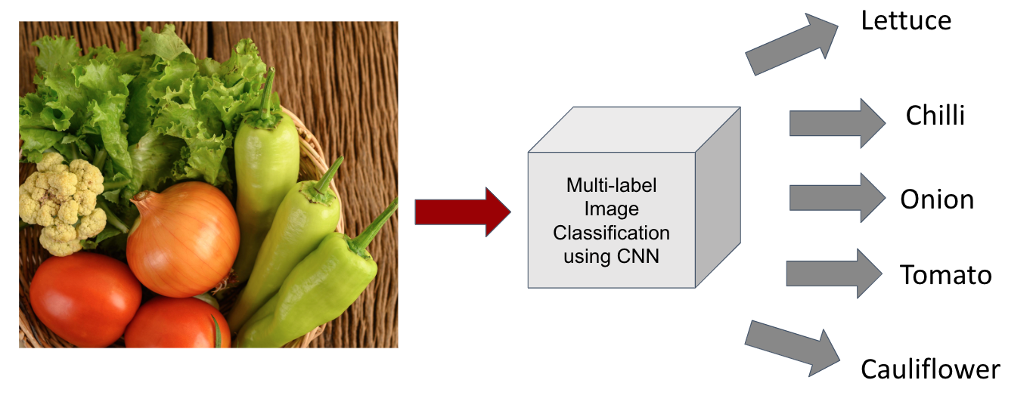

figure 6.2 Multi-label Image Classification

Benefits:

Variety of recipe lists which match the user requirements are recommended. Large number of ingredients are considered while training the model.

Drawbacks:

Huge dataset might lead to more processing time and resource consumption.

Technologies used:

1. TensorFlow - an open-sourced library of Google that is utilized in Android for implementing Machine Learning.
2. TensorFlow Lite - TensorFlow’s lightweight solution for mobile devices. It enables on-device ML inference using a low latency which is why it is very swift.
3. OpenCV - programming functions mainly aimed at real-time computer vision (cv2.VideoCapture)
4. Keras - a Python deep learning library, to re-train the top fully-connected layer of CNN.

# 6.1.5 Design Description

**6.1.5.1 Master Class Diagram**

The following figure is the representation of a master class diagram of the system, which is given at a high level and then broken down into sub levels. Each class has attributes and methods defined.

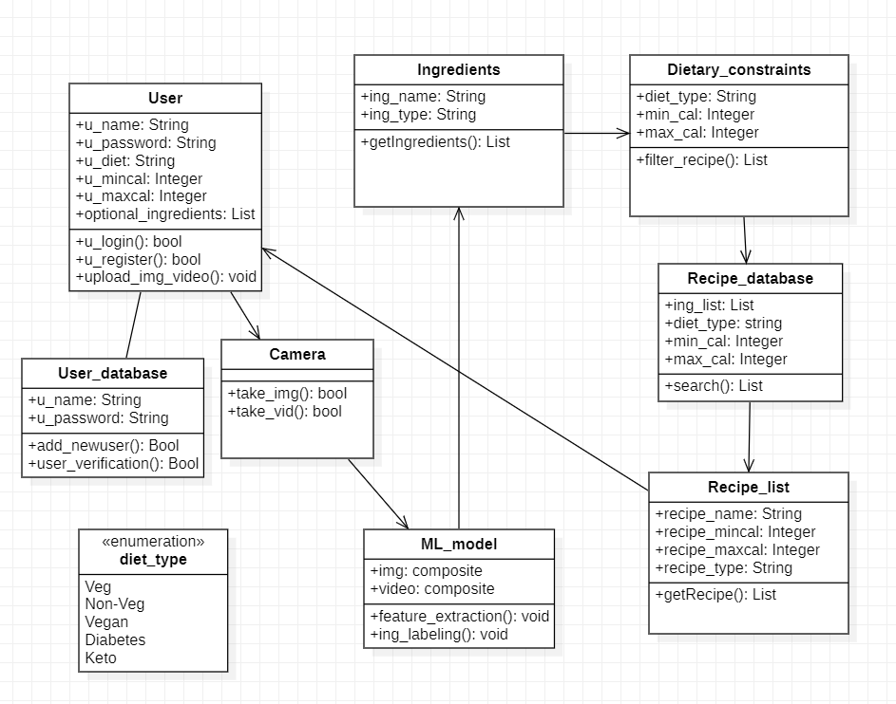

figure 6.3 Master Class Diagram

**6.1.5.2 Reusability Considerations**

* Project Components that are and can be generated with available reusable components.
* Components that can be built in the project for reuse in other projects.

Object detection algorithms can be reused. On training the model on different datasets, it can be able to identify different kinds of objects other than food ingredients.

**6.1.6 Swimlane Diagram**

A swimlane is used in flowcharts,process flow diagrams, that distinguishes job sharing and responsibilities for sub-processes of a business process visually.

It delineates who does what in a process. There three vertical swimlanes, namely,

1. User
2. Model
3. Database

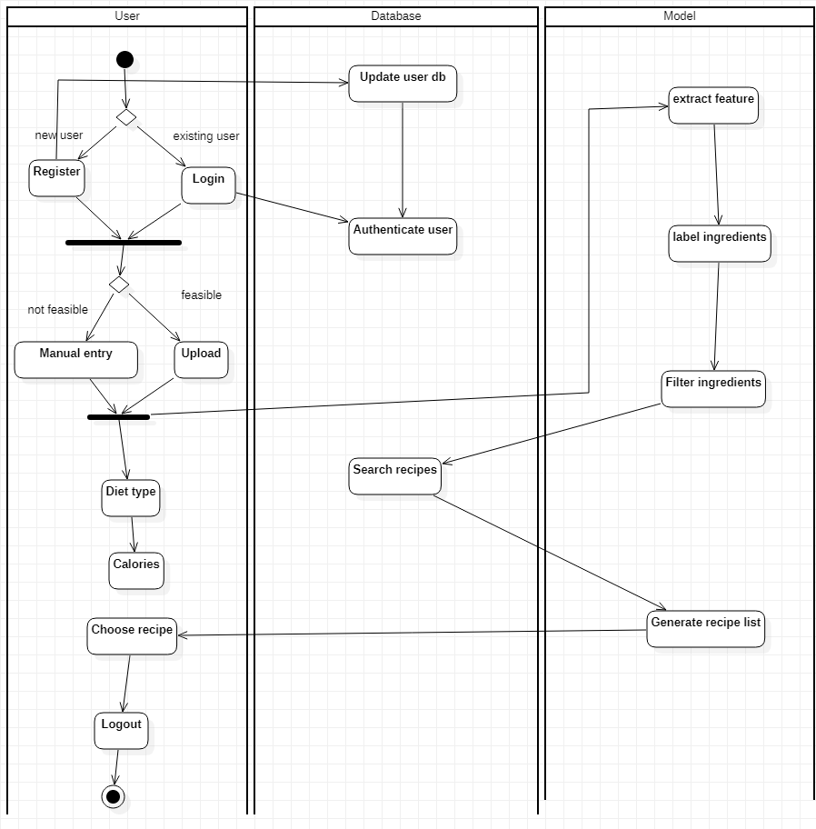

figure 6.4 Swimlane Diagram

**6.1.7 User Interface Diagrams**

A User Interface diagram is modeled in terms of its internal structure and objects comprising it, the same as the rest of the application.

The two actors in our case are:

* User
* Database

This diagram shows the actors along with a rough list of their actions and their relationships.

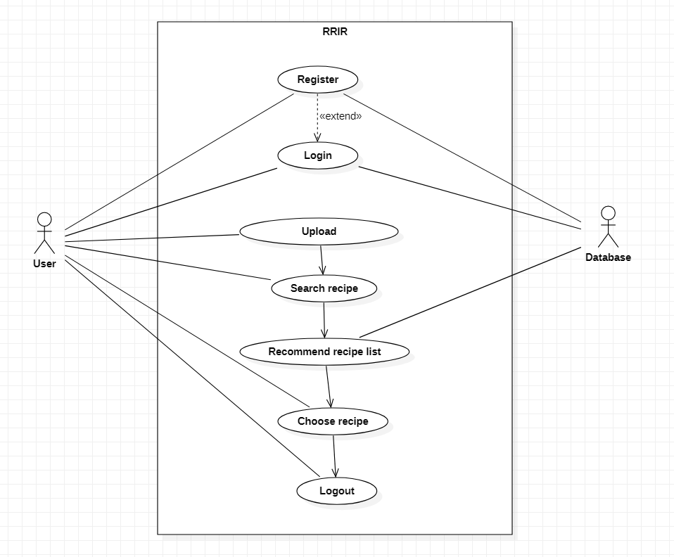

figure 6.5 Use Case 1

This diagram is the expansion of the use case diagram which expands onto the login that the user provides.

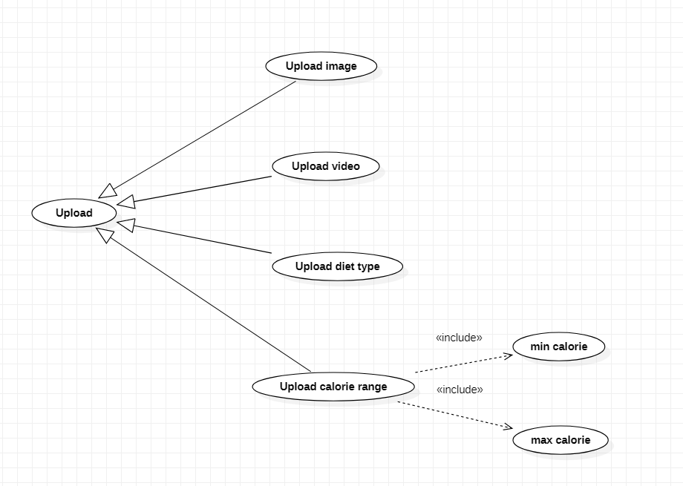

figure 6.6 Use Case 2

This diagram is also a part of the use case diagram which expands onto the rough flow of the program with the actors being User and Database.

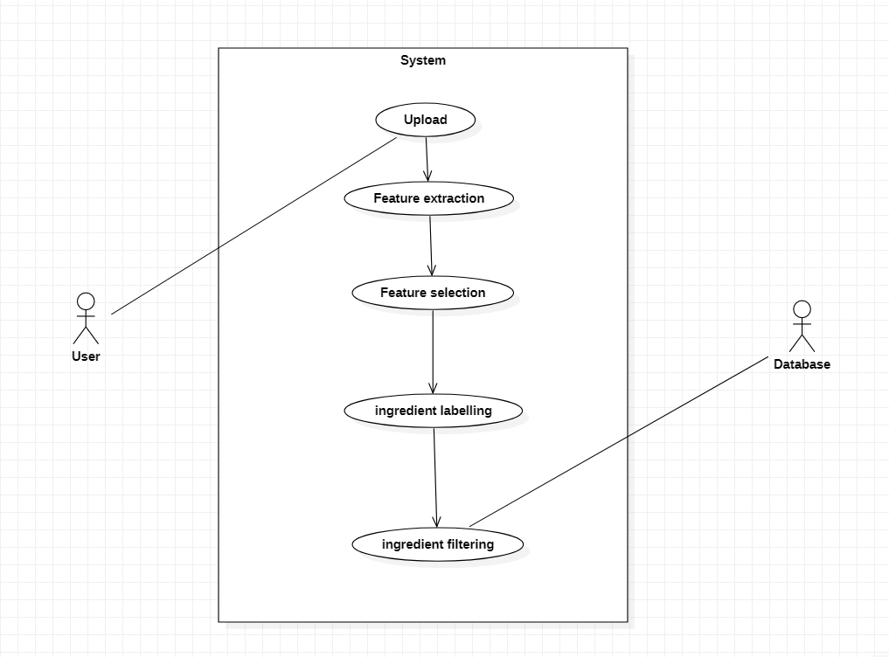

figure 6.7 Use Case 3

**6.1.8 External Interfaces**

The external interface diagram shows the hardware and software interfaces and their relationships with each other. One side is the real time processing and the other is the user interface. It also shows how the actors (User and Database) converses with the two interfaces.

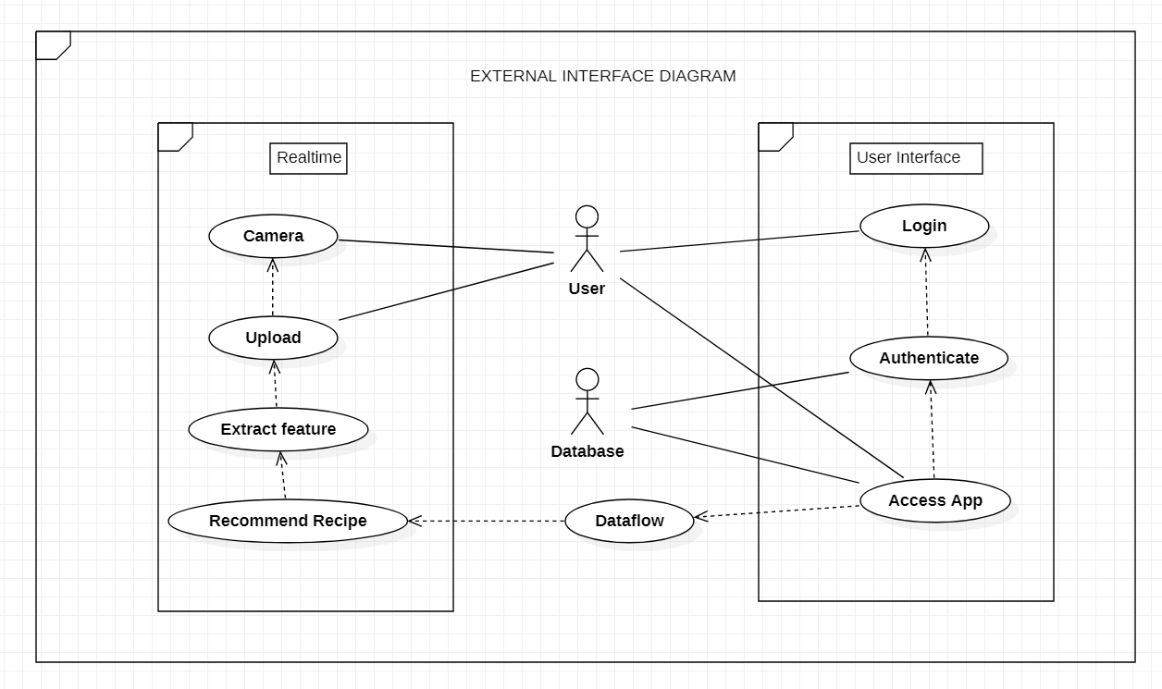

figure 6.8 External Interface Diagram

**6.1.9 Packaging and Deployment Diagram**

It is a UML diagram type which shows the execution architecture of a system, including nodes such as hardware or software execution environments, and the middleware connecting them.

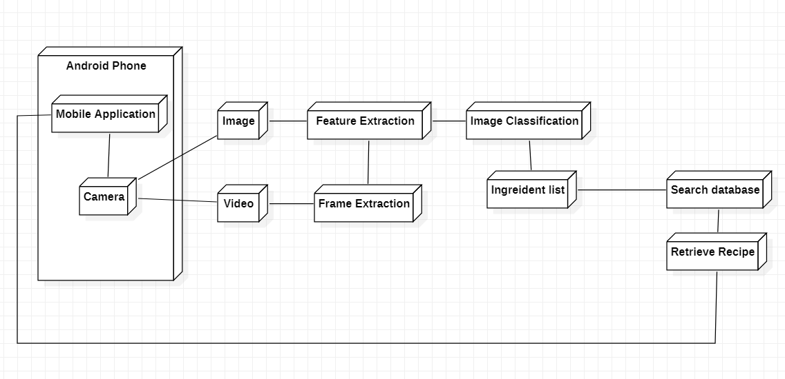

figure 6.9 Packaging and Deployment Diagram

# 

**6.2 Design Details**

**6.2.1 Novelty**

Our project not only focuses on recommending a recipe list, but also, caters to the needs of the user by considering diet choice and calorie range.

**Innovativeness**

As far as our literature survey is concerned, we haven't come across any project which considered the type of diet along with calorie count. This will be inculcated into our project to make it more practical for everyday use.

**6.2.2 Interoperability**

We will create our project such that the server with the model, the database, as well as the user interface will be able to converse with each other and share data consistently. It will ideally support all the latest versions of the operating system from the users side.

**6.2.3 Performance**

Availability: The server should be available on specified time as many users are waiting for the recipe to be generated .

Correctness: Accurate recipes should be recommended to the user in real time.

Usability: The model should handle multiple requests from multiple users.

**6.2.4 Security**

Authentication of user whenever he/she logs into the system. The users will have private user profiles which will store user information.We will have a user-id and a password for authentication which will be logged in in the mobile application.

**6.2.5 Reliability**

The model requires a server with high speed internet capability. The user should be equipped with fair network bandwidth to send images and receive recipes

**6.2.6 Maintainability**

The administrators should ensure that the server is up and running and not overloaded, ensuring it is well maintained.

**6.2.7 Portability**

Portability is the ease with which a software system can be transferred from its current hardware or software environment to another environment. Our system is portable on all android devices released after 2015.

**6.2.8 Reusability**

Object detection is the first phase of our project that can be reused. On training the model on different datasets, it can be able to identify different kinds of objects other than food ingredients. Hence, object detection algorithm can be reused.

**6.2.9 Application compatibility**

The mobile application is Android based, and can be used on all Android devices released after 2015.

**6.2.10 Resource utilization**

Server - server should be up in running along with being scalable at all times. It should be able to handle a large number of requests in real time and process it accordingly.

Storage - the back-end of our system should be able to hold a large database that will be useful for recommending recipe lists.

Android device - the device should be of newer compatible versions with a good working camera and should have enough storage space to accommodate our app.

**CHAPTER-7**

**CONCLUSION OF CAPSTONE PROJECT PHASE - 1**

The project will be implemented in the form of an android mobile application, where the user can login/register and upload various details such as, images, videos(optional), manual entry of ingredients diet type (vegetarian, non vegetarian, vegan, keto diet, diabetic diet) as well as the calorie range (minimum and maximum calorie).

Frame extraction is done in case of video input using OpenCV. The output will be stored as images. These images, along with the images uploaded by the user will be sent to the Multi label CNN model where feature extraction and classification will be done. The list of ingredients will be generated by the model at this stage.

The database will be searched based on the list of ingredients, diet type and calorie range. The matching recipes will be recommended to the user. The user can choose the desired recipe from the list of recipes recommended.

The following features have been completed as for phase 1:

1. Literature survey pertaining to various models and approaches studied and analysed so far.
2. Understanding the user environment to design a compatible user interface.
3. Finalising on the best working models for the functionalities to perform their best.

**CHAPTER-8**

**PLAN OF WORK FOR CAPSTONE PROJECT PHASE - 2**

In the phase 2 of the capstone project for the year 2022, we aim to implement the proposed system mentioned in this report and present a complete working system.

Following are the steps we will follow to implement the project:

1. Completing the preprocessing of the dataset, followed by implementation of the computer vision.
2. We will be working on the muti label CNN classifier model for image feature extraction, detection and image labeling.
3. Training and testing of the model will be carried out.
4. Optimization of the database search in order to make it faster and more efficient will be carried out.
5. An android mobile application will be created which ties it all in with user friendly UI.
6. Evaluation of the system will be done.

We also hope to publish the research paper of our project.

**REFERENCES/BIBLIOGRAPHY**

1. Keiji Yanai, Takuma Maruyama, Yoshiyuki Kawano, “A Cooking Recipe Recommendation System with Visual Recognition of Food Ingredients”, 2014
2. Gangothri R. Sanil , Anusha Anchan , Vijetha Achar, Kavya Hegde, “KNN based Recipe Retrieval using Ingredient Recognition”, 2018
3. W. Ling et al. , “Finding function in form: Compositional character models for open vocabulary word representation,” in Proceedings of the
4. 2015 Joint Conference on Empirical Methods in Natural Language Processing and Computational Natural Language Learning, 2015, pp. 1520-1530
5. Yu-Hsien Ting Qiangfu Zhao, Rung-Ching Chen,”Dietary Recommendation Based on Recipe Ontology”, pp. 1-6, ISSN: 23255986, 6th International Conference on Awareness Science and Technology (iCAST) ,IEEE, 2014
6. Nayani R1 , Pooja KR2 , Ranjani Bahadur3 , Vibha Y4, “RECIPE MANAGEMENT SYSTEM”, International Journal For Technological Research In Engineering Volume 3, Issue 9, May-2016 ISSN (Online): 2347 – 4718.
7. Pathanjali 1 , Vimuktha E Salis , Jalaja G , Latha A, “A Comparative Study of Indian Food Image Classification Using K-Nearest-Neighbour and Support-Vector-Machines”, International Journal of Engineering &Technology, 7 (3.12) (2018) 521-525.
8. Anthimopoulos, M.M.; Gianola, L.; Scarnato, L.; Diem, P.; Mougiakakou, S.G. “A Food Recognition System for Diabetic Patients Based on an Optimized Bag-of-Features Model.” JBHI, 2014 ,18, 1261–1271

**APPENDIX A DEFINITIONS, ACRONYMS AND ABBREVIATIONS**

1. ML : Machine Learning
2. CV : Computer Vision
3. RRIR : Recipe Recommendation Based On Ingredients Recognition Using CV and ML

**APPENDIX B USER MANUAL**

An Upload button will be available on the UI. On clicking on this, the camera on the phone will be accessed and the user will have to click images or shoot videos. Good and high speed internet should be ensured for better experience on the application. Camera quality of more than 10 megapixel is advisable. The ingredients that cannot be scanned, should be manually entered with correct spellings for more accurate recommendations. The diet type, if necessary can be chosen from the predefined list. The user also has the freedom to enter the minimum and maximum calorie value that is desired. On successfully uploading the details, a list of matching recipes will be generated, for the user to choose from.